Wave 5 report

- Please add the tax to the totals
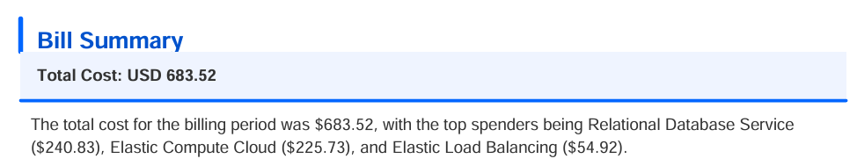
- Graph : Put the % inside the chart and the amount in the label of the pie chart
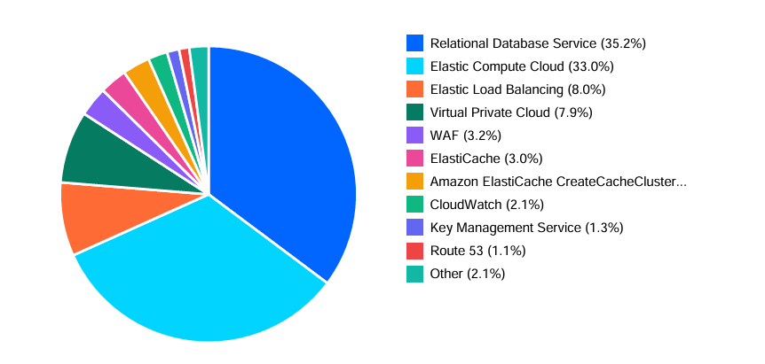
- Rational database – please check the reserved Instance – it is enabled fo DRS too as well as database Saving plan, please add this to the checks
- EC2 (Elastic Compute Plan) – Please check with AWS the rules applied for reserved instance ( buy also “second handed RI plans” in the marketplace) . After the discounts there are options for Spot Instances / Of course also in some cases we can go serverless with Lambda or Fargate. Please check the AWS rules for that in the internet ( AWS OFFICIAL SITE)
- Elastic Load Balancing : Don’t keep it empty , should be “check id the service is Idle”
- VPC : Don’t keep it empty , should be “check id the service is Idle, check downsizing”
- KMS : check unused keys
- S3: check retention period, delete policy

